“Київський фаховий коледж зв’язку”

Циклова комісія комп’ютерної та програмної інженерії

**ЗВІТ ПО ВИКОНАННЮ**

**ЛАБОРАТОРНОЇ РОБОТИ №2**

з дисципліни: «Операційні системи»

**Тема: “Знайомство з інтерфейсом та можливостями ОС Linux”**

Виконавли студенти

групи КСМ-23А

Команда КГК:

Корольов Є.Ю.,

Горохов Д.С. та

Коваленко С.О.

Перевірила викладач

Сушанова В.С.

Київ 2024

**Мета роботи:**

1. 1. Знайомство з інтерфейсами ОС Linux.
2. Отримання практичних навиків роботи в середовищах ОС Linux та мобільної ОС – їх графічною оболонкою, входом і виходом з системи, ознайомлення зі структурою робочого столу, вивчення основних дій та налаштувань при роботі в системі

**Матеріальне забезпечення занять**

1. ЕОМ типу IBM PC.

2. ОС сімейства Windows та віртуальна машина Virtual Box (Oracle).

3. ОС GNU/Linux Ubuntu.

4. Сайт мережевої академії Cisco netacad.com та його онлайн курси по Linux.

**Завдання для попередньої підготовки**

***Готував матеріал студент Коваленко С.***

1. Прочитайте короткі теоретичні відомості до лабораторної роботи та зробіть невеличкий словник базових англійських термінів з питань класифікації ОС.

|  |  |
| --- | --- |
| Термін англійською | Термін українською |
| **Operating System** | Операційна система |
| **Air traffic controller** | Авіадиспетчер |
| Application | Застосунок |
| CPU (Central Processing Unit) | Центральний процесор |
| Disk space | Дисковий простір |
| Crash | Збій (система або програма) |
| Server application | Серверний застосунок |
| Client/server application | Настільний застосунок |
| Linux shell | Оболонка Linux |
| Distribution | Дистрибутив |
| Performance | Продуктивність |

1. Прочитавши матеріал з коротких теоретичних відомостей дайте відповіді на наступні питання:

***Готував матеріал студент Горохов Д.***

* 1. CLI-режим:

**CLI mode (Command-Line Interface)** is a text-based interface where users interact with the system by typing commands. It provides direct control over the system, is lightweight, and consumes fewer resources compared to graphical interfaces. CLI is commonly used for system administration, scripting, and automation tasks, especially on servers and in development environments.

* 1. Термінал на основі графічного інтерфейсу:

A **GUI-based terminal** is a terminal emulator that runs within a graphical interface, allowing users to execute command-line operations in a windowed environment. It combines the power of the CLI with the ease of use of graphical features like copy-paste, multiple tabs, and customizable appearances. Examples include GNOME Terminal and Konsole.

* 1. Віртуальний термінал

A **virtual terminal** is a text-based interface provided by the operating system that allows users to interact with the system directly through a command line. On Linux, multiple virtual terminals are available, typically accessed via keyboard shortcuts (e.g., Ctrl + Alt + F1 to F6). These terminals operate independently of the graphical environment.

**Хід роботи**

***Готували матеріали студенти Корольов Є, Горохов Д, Коваленко С. 401 ауд.***

1. Робота в графічному режимі в ОС сімейства Linux:.
   1. Оберіть графічну оболонку для ОС сімейства Linux, яку  ви хочете розглянути ***(в 401 ауд. це Gnome)***. Розгляньте структуру робочого простору користувача, та опишіть основні його компоненти:

* Основне меню:

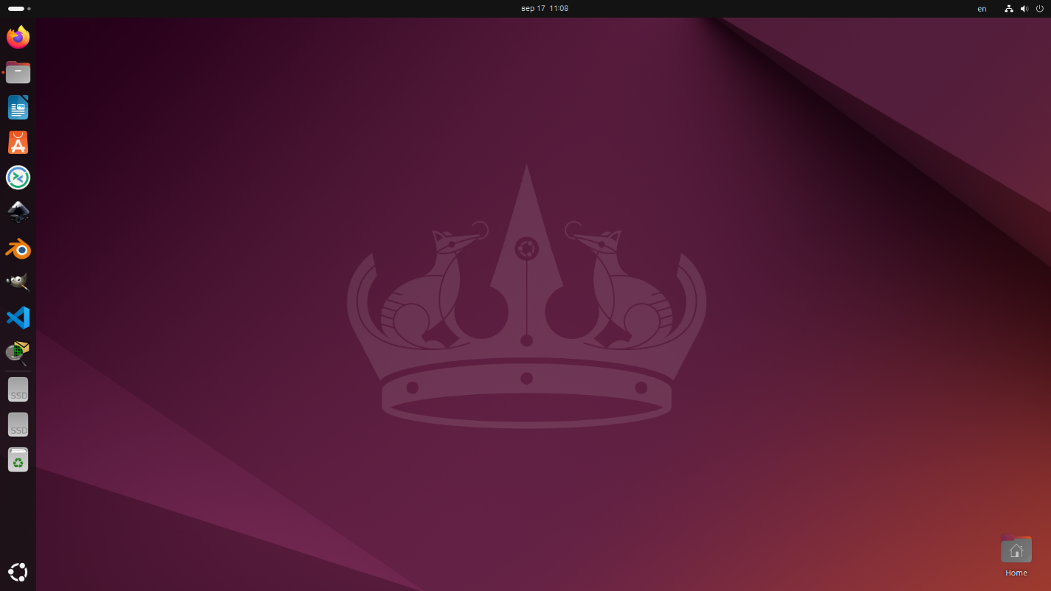

* Панель швидкого доступу:
* Пошук:
* Доступ до нових робочих столів:?

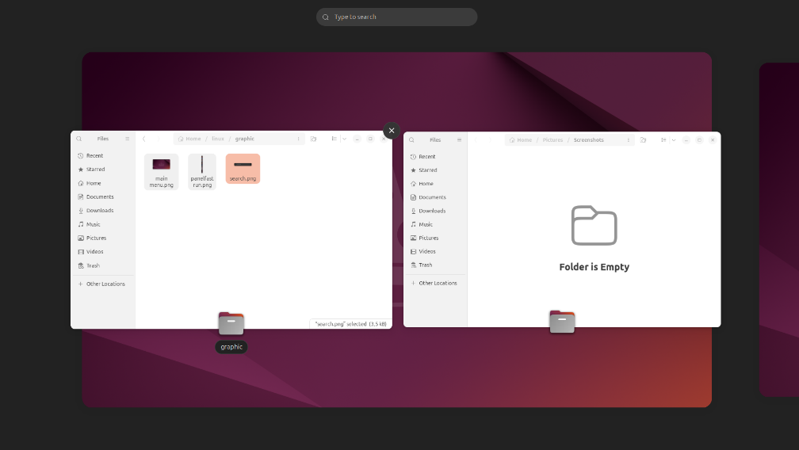

* 1. Запуск програм. Дослідіть можливості запуску додатків різними способами (описати спосіб і по можливості показати скріншоти)
* Запуск програм через панель швидкого доступу:
* 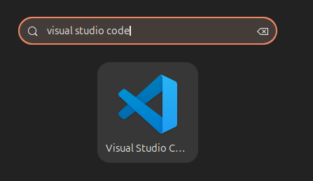Запуск програм через пошук в меню/глобальне меню
* 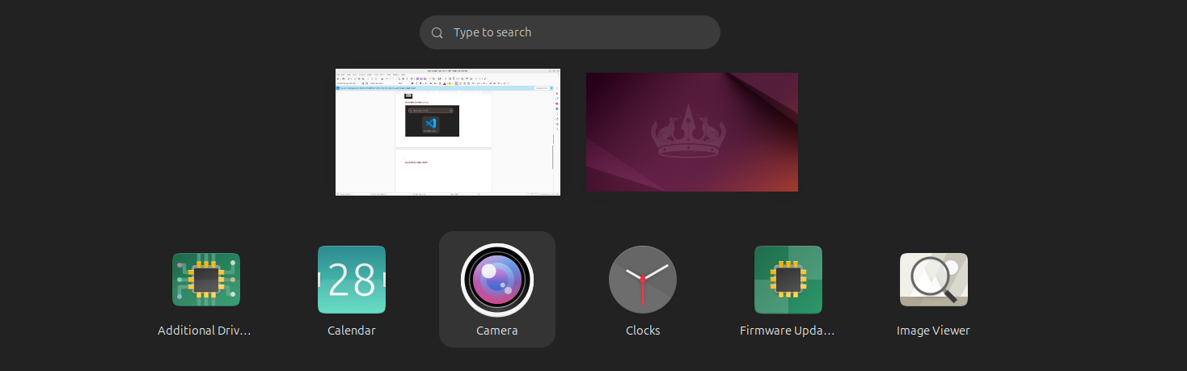Запуск програм через віджет запуску:
  1. Вихід з системи та завершення роботи в Linux. Як виконати в графічному інтерфейсі наступні дії (наведіть скріни):
* 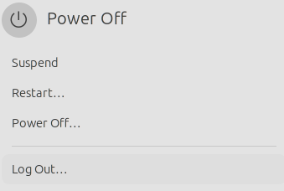Зміна користувача на root:
* 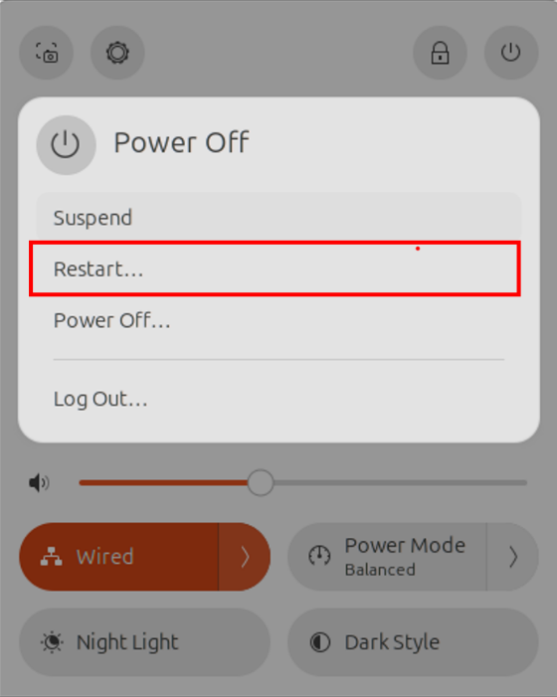Перезавантаження системи:
* Вимкнення системи:

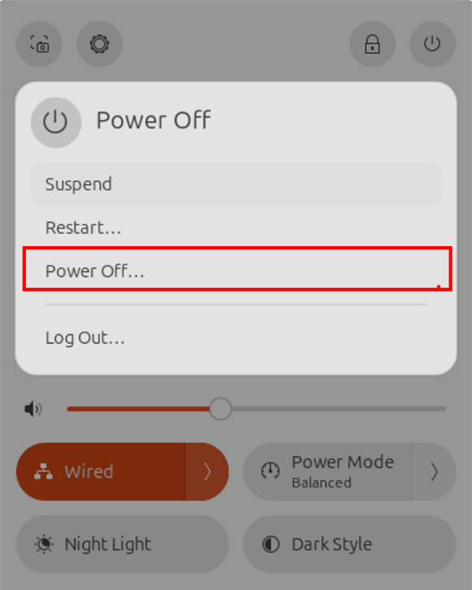

1. Робота в середовищі мобільної ОС.
   1. Опишіть головне меню вашої системи, який графічний інтерфейс вона використовує?

The **main menu** of the Samsung Galaxy A23 is based on **Samsung's One UI** interface, which runs on top of **Android**. It features a clean and user-friendly design with easy navigation. The main elements include:

1. **App Drawer**: A grid of installed apps, accessible by swiping up from the home screen.
2. **Notification Panel**: Accessed by swiping down, it shows notifications and quick settings like Wi-Fi, Bluetooth, and brightness.
3. **Home Screen**: Displays widgets, app shortcuts, and Google search bar.

One UI focuses on large, easy-to-read icons and smooth transitions for an intuitive experience.

* 1. Опишіть меню налаштувань компонентів мобільного телефону.

The **Settings menu** on the Samsung Galaxy A23, powered by **One UI**, is organized into various categories for easy navigation and customization. Key sections include:

1. **Connections**: Manage Wi-Fi, Bluetooth, mobile networks, and airplane mode.
2. **Sounds and Vibration**: Adjust ringtone, volume, and notification settings.
3. **Display**: Control brightness, screen timeout, and Dark Mode.
4. **Notifications**: Customize notification preferences for apps.
5. **Biometrics and Security**: Set up fingerprint, face recognition, and privacy options.
6. **Battery and Device Care**: Monitor battery usage, storage, and device performance.
7. **Apps**: Manage installed applications and permissions.

Each section allows you to fine-tune specific components and settings of the device.

* 1. Використання комбінацій клавіш для виконання спеціальних дій.

Using **keyboard shortcuts** on a mobile device like the Samsung Galaxy A23 can make tasks quicker and more efficient. Common key combinations include:

1. **Power + Volume Down**: Takes a screenshot.
2. **Power + Volume Up**: Accesses the recovery mode (when the phone is turned off).
3. **Power + Hold**: Opens the power menu for restarting, shutting down, or emergency mode.
4. **Double-press Power**: Quickly opens the camera.
5. **Volume Up + Volume Down (Hold)**: Enables accessibility features like TalkBack.

These shortcuts help users perform tasks efficiently without navigating through menus.

* 1. Вхід у систему та завершення роботи пристрою. Особливості налаштувань живлення батареї:

**Logging In and Powering Off the Device:**

On the Samsung Galaxy A23, logging in typically involves:

1. **Unlocking the Screen**: You can use methods like fingerprint recognition, face recognition, a PIN, or a password.
2. **Powering Off**: Hold the **Power** button and choose between powering off, restarting, or entering emergency mode.

**Battery Power Settings:**

Samsung provides several power management features:

1. **Power Saving Mode**: Reduces battery usage by limiting background apps, reducing performance, and lowering screen brightness.
2. **Battery Usage**: Shows how much power each app consumes.
3. **Adaptive Battery**: Limits battery use for less frequently used apps.
4. **Optimized Charging**: Adjusts charging speed to prolong battery lifespan.

These settings help extend battery life and optimize power consumption.

**Відповіді на контрольні запитання**

***Готував матеріал студент Горохов Д.***

1. Наведіть приклади серверних додатків Linux для сервера баз даних, серверів розсилки повідомлень та файлообмінників.

Database servers:

* MySQL: A relational database popular for web applications.
* PostgreSQL: An object-relational database with powerful features.

Messaging servers:

* RabbitMQ: A message broker that supports multiple protocols.
* Apache Kafka: A distributed platform for streaming data.

File sharing services:

* Nextcloud: An open source file synchronization and sharing platform.
* Samba: Allows file sharing between Windows and Linux systems.

1. Порівняйте оболонки Bourne, C, Bourne Again (Bash), the tcsh, Korn shell (Ksh) та zsh.

1. Bourne Shell (sh).

- Features: Original Unix shell, simple, basic syntax.

- Usage: Scripts for compatibility with different systems.

2. C Shell (csh).

- Features: C-like syntax, interactive features (command history, aliases).

- Disadvantages: Difficult for scripting, less reliable.

3. Bourne Again Shell (Bash)

- Features: Most common, advanced syntax, interactive features.

- Usage: Standard shell in most Linux distributions.

4. tcsh

- Features: Improved version of csh, easier auto-completion, command history.

- Usage: Useful for those who are used to csh.

5. Korn Shell (ksh).

- Features: Combines the capabilities of sh and csh, powerful for scripting.

- Usage: Popular in corporate Unix environments.

6. Z Shell (zsh).

- Features: Most flexible, plug-in support, advanced autocomplete.

- Usage: Among developers and users who value customization.

1. Для чого потрібен менеджер пакетів. Які менеджери пакетів ви знаєте у Linux?

A package manager is a set of software in Linux that installs, configures, uninstalls, and updates both individual packages (programs) and the entire system. Package Manager in Linux:

* 1. APT.
* Distributions: Debian, Ubuntu.
* Commands: apt, apt-get.
  1. YUM/DNF
* Distributions: CentOS, Fedora.
* Commands: yum, dnf.
  1. RPM
* Distributions: RHEL, openSUSE.
* Commands: rpm.

4. Pacman

- Distributions: Arch Linux.

- Commands: pacman.

1. Snap

* Distributions: Ubuntu.
* Commands: snap.

1. Flatpak

* Distributions: Many distributions.
* Commands: flatpak.

1. Які засоби безпеки використовуються в Linux?

Linux is known for its reliability and security due to:

Strict access rights: Each file has an owner, and only they can modify it.

Regular updates: Systematic updates close vulnerabilities in the software.

Firewalls: Filter network traffic by blocking malicious connections.

Intrusion detection systems: Monitor the system for suspicious activity.

Encryption: Protects data from unauthorized access.

The principle of least privilege: Users have only the rights they need to work.

Optional:

Two-factor authentication: Adds an extra layer of protection.

Access control systems: Centrally manage access rights.

Anomaly detection systems: Detect deviations from normal operation.

For maximum security:

Update your system regularly.

Create backup copies of your data.

Train users on security basics.

Monitor your system for threats.

1. Чому використання віртуалізації зараз стало таким актуальним?

Virtualization allows you to run multiple operating systems on one computer. It's like having severalcomputers in one.

Why is it so convenient?

Cost savings: Less hardware is used, which means less energy and maintenance costs.

Flexibility: It is easy to add or remove virtual machines and change their resources.

Reliability: If one virtual machine fails, the others continue to work.

Management: All virtual machines can be managed from a single location.

Security: Each virtual machine is isolated from the others.

Where is it used?

Companies: To run different services on the same server.

Clouds: To provide computing resources on a subscription basis.

Development: For testing software.

Training: To create virtual laboratories.

1. Як ви розумієте поняття контейнеризації?

Containerization is a way to pack software along with all its dependencies (libraries, tools, etc.) into one isolated package called a container. Imagine a box that has everything you need to run a program, no matter what computer it's on.

Why is this convenient?

Portability: Containers can be moved between different environments (for example, from a local computer to the cloud) without any problems.

Speed: Containers start up much faster than virtual machines.

Efficiency: Containers use fewer resources than virtual machines.

Isolation: Each container is an isolated environment that reduces the risk of conflicts between different applications.

What is this used for?

Software development: Containers allow developers to build and test applications in identical environments.

Application deployment: Containers simplify the process of deploying applications in the cloud or on local servers.

Microservice architecture: Containers are ideal for creating microservices - small, independent services that work together.

1. Які переваги/недоліки використання програмного забезпечення з відкритим кодом?

The advantages of the air barrier:

* Free of charge: The most obvious advantage is the absence of license fees.
* Transparency: Open source allows anyone to check it for vulnerabilities and bugs.
* Flexibility: The ability to modify the software to suit your needs.
* Community: A large community of developers helps to quickly solve problems and develop new features.
* Reliability: Due to the large number of users and developers, the software is usually more reliable and stable.
* Innovation: Open source encourages the development of new technologies and approaches.

Disadvantages of open source:

* Lack of technical support: As a rule, users of FOSS have to solve problems on their own or seek help from the community.
* Difficulty in use: Some PPCs can be difficult to set up and use, especially for users without programming experience.
* Security: While open source allows vulnerabilities to be discovered more quickly, it can also be exploited by malicious actors.
* No guarantees: There is no guarantee that an IPS will work properly or be supported in the future.
* Choosing from a large number of options: The large number of available firewalls can make it difficult to choose the most appropriate solution.

When should I use a firewall?

* For smaller projects: A PSC can be a great choice for smaller projects with limited budgets.
* For projects that require high flexibility: The ability to modify the code allows you to adapt the software

1. Скільки активних віртуальних консолей (терміналів) може бути у процесі роботи Linux по замовчуванню. Як їх викликати та між ними перемикатися? Наведіть приклади.

By default, **Linux** provides **6 active virtual consoles (terminals)** during operation. You can access them using the following keyboard shortcuts:

1. **Ctrl + Alt + F1** to **Ctrl + Alt + F6**: These shortcuts switch to virtual consoles 1 through 6, where you can log in and run commands.

To return to the **graphical interface** (if running), you typically use **Ctrl + Alt + F7** (on some systems, it may be **F1** for the graphical session).

For example:

* **Ctrl + Alt + F2**: Switches to the second terminal.
* **Ctrl + Alt + F5**: Switches to the fifth terminal.

These virtual consoles allow multiple users or sessions to operate simultaneously.

1. Яка віртуальна консоль (термінал) виконує функцію графічної оболонки?

A virtual console (terminal) that performs the functions of a graphical shell, usually an X server (for example, X Window System or modern analogues such as Wayland). The X server is responsible for rendering graphical elements and user interaction with the GUI, but its work is complemented by a display manager (e.g. GDM, LightDM, SDDM) and a window manager (e.g. GNOME, KDE, Xfce). These components together form a graphical shell, allowing the user to work in a graphical environment.

The graphical environment is run on one of the virtual consoles, for example, tty7, while the other consoles (for example, tty1 - tty6) usually remain text terminals.

1. Чи можлива реєстрація в системі Linux декілька разів під одним і тим же системним ім’ям? Які переваги це може надати?

On a Linux system, you cannot log in multiple times with the same system name within the same session. Each user can only have one active session associated with his or her account on one virtual console or graphical session. This restriction is part of the Linux security system, which ensures the uniqueness of accounts and the correct functioning of user processes.

However, it is possible to open multiple sessions under the same account on different virtual consoles or in different graphical sessions at the same time. To do this, you can use the following mechanisms:

Switching between virtual consoles (ttys) - For example, a user can log in to one console (e.g., tty1) and then open a new session on another (e.g., tty2) using the same username.

Remote connections - You can simultaneously connect to the system through multiple terminals using SSH or RDP protocols using the same account.

The advantages of this approach:

* Performing different tasks in parallel - The user can work on multiple terminals or graphical environments at the same time, for example, performing different tasks or running independent processes.
* Security and control - You can conveniently switch between sessions without logging out or interrupting other sessions.
* Flexibility in the use of resources - The ability to use different workspaces or consoles for convenient workflow organisation.

**Висновки**

В ході виконання лабораторної роботи мною було досліджено … , більш детально теоретично досліджено питання …. Отримано практичні навики роботи з командами …, налаштування … ***(Якщо виникли труднощі, то їх описати)***